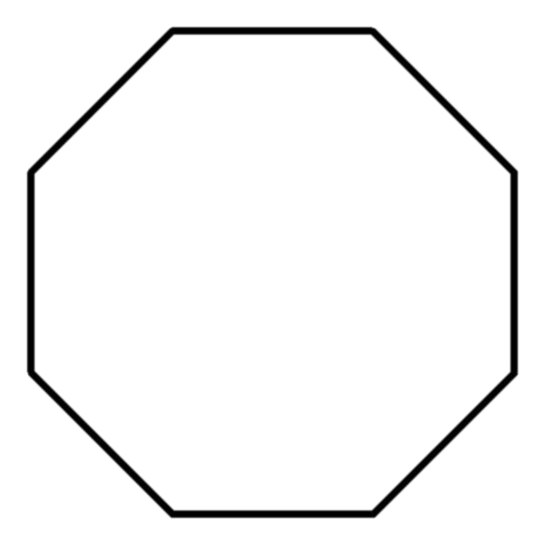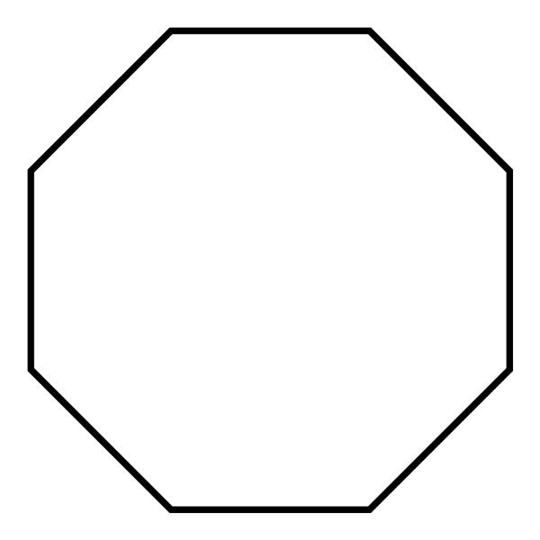

Cut 1 from cardstock for stamped background

Cut 1 on fold for card blank